Assignment 2

Sachin Shubham

2/6/2021

Your friend from the medical department asked for your help with the project. You have to compare an outcome between two groups. Specifically:

1.compare infants birth weight between smoking and non-smoking mothers

2.compare infants birth weight between agroup of mothers with a presence of uterine irritability and a group of mothers without it

You need to run hypothesis tests to assess whether the trends you observe from the descriptive analysis are statistically significant. Use MASS::birthwt dataset. Prepare one small report using the R markdown. Include in the report your code, comments on the output of the tests and brief summary (Example: ”Our study finds that birth weights are on average ??? in the non-smoking group compared to the smoking group (t-statistic ??, p=??, ??% CI [??, ??]g)”).

library(tidyverse)

## -- Attaching packages --------------------------------------- tidyverse 1.3.0 --

## v ggplot2 3.3.3 v purrr 0.3.4  
## v tibble 3.0.5 v dplyr 1.0.3  
## v tidyr 1.1.2 v stringr 1.4.0  
## v readr 1.4.0 v forcats 0.5.1

## -- Conflicts ------------------------------------------ tidyverse_conflicts() --  
## x dplyr::filter() masks stats::filter()  
## x dplyr::lag() masks stats::lag()

birthwt <- as_tibble(MASS::birthwt)  
colnames(birthwt) <- c("birthwt.below.2500",   
 "mother.age",  
 "mother.weight",  
 "race",  
 "mother.smokes",  
 "previous.prem.labor",  
 "hypertension",  
 "uterine.irr",  
 "physician.visits",  
 "birthwt.grams")  
  
#(1) compare infants birth weight between smoking and non-smoking mothers  
  
birthwt <- birthwt %>%  
 mutate_at(c("mother.smokes", "birthwt.below.2500"),  
 ~ recode_factor(.x, `0` = "no", `1` = "yes"))  
  
qplot(x = mother.smokes, y = birthwt.grams,  
 geom = "boxplot", data = birthwt,  
 xlab = paste("Mother Smoke, n = ", nrow(birthwt)),   
 ylab = "Birthweight (grams)",  
 fill = I("lightblue"))

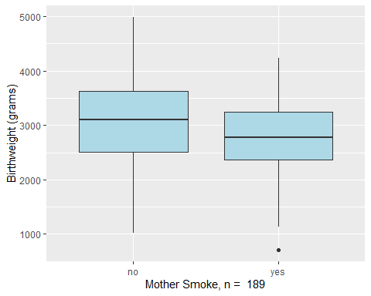

birthwt %>%  
 group_by(mother.smokes) %>%  
 summarize(num.obs = n(),  
 mean.birthwt = round(mean(birthwt.grams), 0),  
 sd.birthwt = round(sd(birthwt.grams), 0),  
 se.birthwt = round(sd(birthwt.grams) / sqrt(num.obs), 0))

## # A tibble: 2 x 5  
## mother.smokes num.obs mean.birthwt sd.birthwt se.birthwt  
## * <fct> <int> <dbl> <dbl> <dbl>  
## 1 no 115 3056 753 70  
## 2 yes 74 2772 660 77

birthwt.t.test <- t.test(birthwt.grams ~ mother.smokes, data = birthwt)  
birthwt.t.test

##   
## Welch Two Sample t-test  
##   
## data: birthwt.grams by mother.smokes  
## t = 2.7299, df = 170.1, p-value = 0.007003  
## alternative hypothesis: true difference in means is not equal to 0  
## 95 percent confidence interval:  
## 78.57486 488.97860  
## sample estimates:  
## mean in group no mean in group yes   
## 3055.696 2771.919

birthwt.t.test$p.value

## [1] 0.007002548

#Our study finds that birth weights are on average 3055.696 in the non-smoking  
#group compared to the average 2771.919 in smoking group (t-statistic 2.7299,  
#p=0.007003, 95% CI [78.57486, 488.97860]g). A small p(<=0.05), reject the null  
#hypothesis. Therefore, this is strong evidence that the null hypothesis is  
#invalid  
  
#(2)compare infants birth weight between a group of mothers with a presence of  
#uterine irritability and a group of mothers without it  
  
birthwt <- birthwt %>%  
 mutate_at(c("uterine.irr", "birthwt.below.2500"),  
 ~ recode_factor(.x, `0` = "without uterine", `1` = "with uterine"))  
qplot(x = uterine.irr, y = birthwt.grams,  
 geom = "boxplot", data = birthwt,  
 xlab = paste("Uterine, n = ", nrow(birthwt)),   
 ylab = "Birthweight (grams)",  
 fill = I("lightblue"))

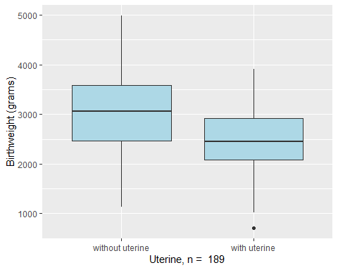

birthwt %>%   
 group_by(uterine.irr) %>%  
 summarize(num.obs = n(),  
 mean.birthwt = round(mean(birthwt.grams), 0),  
 sd.birthwt = round(sd(birthwt.grams), 0),  
 se.birthwt = round(sd(birthwt.grams) / sqrt(num.obs), 0))

## # A tibble: 2 x 5  
## uterine.irr num.obs mean.birthwt sd.birthwt se.birthwt  
## * <fct> <int> <dbl> <dbl> <dbl>  
## 1 without uterine 161 3031 694 55  
## 2 with uterine 28 2449 742 140

birthwt.t.test <- t.test(birthwt.grams ~ uterine.irr, data = birthwt)  
birthwt.t.test

##   
## Welch Two Sample t-test  
##   
## data: birthwt.grams by uterine.irr  
## t = 3.8615, df = 35.696, p-value = 0.000455  
## alternative hypothesis: true difference in means is not equal to 0  
## 95 percent confidence interval:  
## 275.8913 886.6553  
## sample estimates:  
## mean in group without uterine mean in group with uterine   
## 3030.702 2449.429

birthwt.t.test$p.value

## [1] 0.0004550226

#Our study finds that birth weights are on average 3030.702 in the without  
#uterine group compared to the average 2449.429 in with uterine group  
#(t-statistic 3.8615, p=0.000455, 95% CI [275.8913, 886.6553]g). A small  
#p(<=0.05), reject the null hypothesis. Therefore, this is strong evidence that  
#the null hypothesis is invalid